Magic Invitational Report: Scott Richards
Scott Richards
Everybody knows that the people in South America are extremely friendly. Over there staying and talking with friends until sunrise is a way of being.
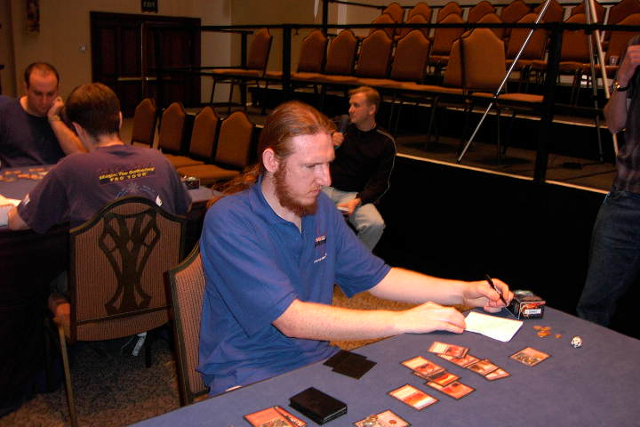
I was born in New Zealand. Everybody knows that talking in New Zealand is the best way to get in trouble. You just keep things to yourself as much as you can. Of all Magic players, I think Gary Wise would blend into Uruguay quite better than I do, but he would be a real foreigner in New Zealand, if you know what I mean...
Anyway, here I am. A Kiwi-Uruguayan, Latin Champ, Southern Hemisphere type, representing the less-developed Magic communities, playing the Invitational in another Southern Hemisphere locale, trying to do my best with a real bicultural problem: THE NEED TO TALK ABOUT IT!
Because at the end of the day, I live in Uruguay, I love the language, the music, the pizza, and the girls. But I just don't feel like communication will be a passion in my life.
But anyway, this is the report of the Invitational and I feel myself as Uruguayan as possible. I'll talk to you as if we were in Montevideo, discussing the game until 4am, watching "el Rio de la Plata".
For doing that I need a drink. Pubs are packed in New Zealand because people need to a little motivation to talk. That is another problem... I really don't drink much. But, let's have one drink, just for bridging this cultural gap. Deal?
Let's have a talk over a glass of South American wine.
I'll be talking to you, if you don't mind...
Let's have a toast, then...
For the Uruguayan players:

SALUD!
- Let me tell you, that it was Ice Age time when I started playing Magic.
- In 1997, Mirage times, I won my first "important tournament" in Nelson. Imagine how important at the time! 38 players, all from the South Island of New Zealand .
- Where? Grab a map, dude!
- My first draft ever, and I'm sure the first also for the TO's because after the draft we played six rounds of Swiss, and then Top 8 with the same draft... That was cool!
- Ok! I know you are expecting me to talk about South Africa.
- What does all of this have to do with anything? You can ask me, suddenly in front of Kai, not knowing if I should play Dwarf A or Dwarf B and feeling the sweat running down my back, and having in my hands the possibility of making the final?
- THE FINAL OF THE INVITATIONAL! YOU KNOW WHAT I MEAN?
- I was really scared that somebody would of notice that I was really scared...
- Even after I felt I was not that bad at the Auction... I was doing well.
- Yes, me, the Kiwi-Uruguayan- "Who's this guy that nobody knows?" Yes. I was 10-4 until the last round in the auction but this is not the time to tell you that, because what I'm telling you now is that night in Nelson... Look at the New Zealand map again, please!
- There, just at the top of the South Island...
- No, not in Antarctica man! A little bit above that.
- There you are! That island, the best in the world as everybody knows. Ok...?
- Well, that night in Nelson, I told myself that I WAS GOING TO MAKE THE INVITATIONAL. And this is what I was trying to tell you....
- Let's have another toast, man.
- I feel Mexican now. For the Mexican players:

SALUD!
- Where was I?
- You are right... on my way to the Invitational. Now, going to South Africa, with my friend James White. He is a real cool guy, the best you can get for a North Islander... It was great that he wanted to play the Grand Prix in Cape Town, so we went together.
- But let's talk about Cape Town: The situation for the Invitational is a very special event, when you look at it from this part of the world, you know? It's not like any other tournament. Not a Pro Tour, not even the Masters. It's like you can REALLY get to prove yourself with only 16 great players.
- Yeah, they were all top players, except for me. And everybody played for fun, for the game. No money on the line. Just pride. I mean... a sort of the Olympics of Magic. You do your best and you have fun and make friends at the same time.
- And, you know, when you think that you have spent so many years playing Magic and you want a new, strong challenge, THE CHALLENGE... you think of the Invitational.
- What about the people in Latin America? Of course, they are looking at you, man. You are representing them. Then, it's not only you playing... it's all your friends. Can you imagine? Me, the red haired "gaucho charrua"?
- I needed to do well for me, but the real pressure was trying to do my best for them... There are real nice people and good players there, and it's not that easy to achieve a level in Magic or in anything, when you are not in the north of the world. For most of us, it's just too expensive to travel there... I wanted them to be recognized, too. That was my job...
- A toast for Brazil. For the Brazilian players:

SALUD!
- Let's go back to South Africa. We crashed in a hotel on Saturday night after more than 20 hours of flying. When I looked out the window the next morning, the first things I saw in Cape Town daylight were Gary Wise and Kai Budde! Pretty amazing! We felt a little bit at home then. We ran to catch up with them.
- The first couple of days there was a few of us. We had a nice group: Clegg, Benafel, Kibler, Wise, Budde, a few South African Organizers, James and I. We did a lot of different things: Drumming-drinking. Sailing-drinking. Talking-drinking. Playing a litlle bit of Magic-drinking. Eating-drinking... Stuff-drinking. And eventually we went out for a drink.
- Of course, we got to see some of Cape Town. Nice place, nice and friendly people. Regrettably the majority, if not nearly the total, of the South African players were from Europe... but anyway, we got to see Nelson Mandela's prison!
- Kind of weird from a Southern point of view. That experience reminds me of Opposition's flavor text. "Urza's says he's sane. Perhaps, but measures among planeswalkers are hard to come by..." Anyway. Don't go there, man... I was telling you that we got to see Mandela's prison. Pretty moving for me...
- When everybody else was there, we went for wine tasting... before sailing! Can you imagine man? Good as gold, mate! But the best was playing with some kittens, cheetah kittens! And to finish off the day we went to an African restaurant and we managed to get to bed around midnight!
- It's a real good idea having extra days before starting the event. It gave me time and space and a way to get to know the other guys. Thanks Mark! We appreciate it!
- Talking about the organizers, let's have a toast for them. For Mark and the rest of the staff:

SALUD!
- Oh yeah, I'm not forgetting it, the tournament itself was great. Each day was long, if you ask me. Would of been really better having four days to play instead of three, I mean, you don't want to start first thing in the morning and going until midnight, do you? That happened on the first day.
- No, that's not an excuse for my first day performance. I just sucked on the first day.
- Look. We started with Duplicated Limited, same sealed deck for every one. Building the deck was great but I, the Kiwi-Uruguayan, tried to prove myself different. It just screwed me up. This is a great format to really throw someone into the deep end.
- Playing it... not as exciting. The cards they chose this year made it boring. Everything came down to mana. Since all the cards were so bad, it came down to percentages of lands and spells drawn. Not much you can do...
- Yes, I went 1-2. I beat Fujita because he got mana problems twice, as was so common with this particular Duplicated Limited. I lost to Dan Clegg and Tom van de Logt.
- After that we played 5-Color, the only format I practiced with my bros, Martin, Damian and Julian Brown-Santirso. But the cards were all thanks to the help of Ray Walkinshaw, Andy Fletcher and James White, who lent me more than 250 cards & sleeves! Thanks guys! These guys are all VERY cool, even my bros.
- By the way, the most difficult thing in 5-Color is shuffling your deck. Take care, you need to be in good shape!
- In this case, a lot came to luck. The only match I won was against Scott Johns. He deserved to win. I was lucky to cut to a Mox in the final game & then go on to win 1-2, because of the monetary value rules.
- I lost to Antoine Ruel. In this game I had the most fun when he Haunting Echoed me when I had more than 50 cards in the graveyard. I think it took like 20 minutes to find all the cards in my deck! And believe it or not, we were laughing the whole time. He's a great guy to play with.
- Playing against Chris Benafel, it was a close game, but I needed to cut to a 5 dollar card & only got a Druid Hermit, 3 dollars. We then played the game & I won it.
- Also my idea of playing a combo in 5-Color wasn't the best. I only pulled it off twice...
- But, you know, what was interesting after that bad, bad day? At 2-4, I stopped worrying about winning. We went for our "midnight dinner" with James and I told myself: "Man, what are you worrying about? Have fun and you'll play better."
- And so I did.
- What about a toast for the Argentinian people? Players from Argentina:

SALUD!
- As you know, the second day was pretty different for me. We started Rotisserie Draft after sleeping only a few hours. I'm sure that was my only advantage over Jon Finkel. I don't believe he got much sleep that night and that allowed me to beat him 2-1.
- I'm sure Jon & I took the right colors though, we drafted green-red. Green was particularly strong. You get a bunch of cheap creatures for start and then you finish with Overrun.
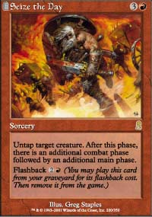
- I beat David Price with Seize the Day, which was effectively a Time Walk in that game.
- The match I enjoyed a lot was against Michael Pustilnik. It was very close! A real difficult match, with a lot of options. The type of game I like the most.
- I went 3-0 in the morning.
- Standard was next up. I made a deck at lunch time. I had no preparation at all for Standard, but I got a gut feeling: stick with THE STICK, the same colors: red-green, a very similar deck to the one I played at PT-Tokyo, just with some new cards.
- I beat Kibler 2-0 who was playing Blue-Green Opposition.
- Then my sideboard let me win against Pikula. He was playing a similar deck but more tuned for the mirror match. After sideboarding my extra mountain, Flametongues and Shivan Wurms were key.
- And then my last match against Cornelissen. He was playing islands. No chance against my deck. I beat him 2-0.
- I went 3-0 again in the format.
- You are right, it felt kind of good going 6-0 Day 2. It put me 4th in seed for the Auction.
- But for talking about the last day we need another toast.
- Now for the Chilean players:

SALUD!
- Well, how can I explain to you how it feels to be in the Auction? You need to be really relaxed. Pay careful attention, like in a Rochester. That was real fun!
- All the decks were going for a lot more than I thought they would. I was enjoying the bidding process, you know. Pretending to go for a deck just so that an opponent would have to pay more for it. It was the only way. And I kept on staying back until the end, were I got the beloved Dwarves that every one was bashing the whole weekend.
- My brothers believed that I got the dwarves because it was the leftover. No way man, I chose the not-that-bad dwarves after doing a lot of anti-bidding stuff. I tell you. That was FUN!
- I beat the "big" Ruel that was playing Thallids and Gary Wise with his land deck. They just couldn't handle the power of the Dwarves.
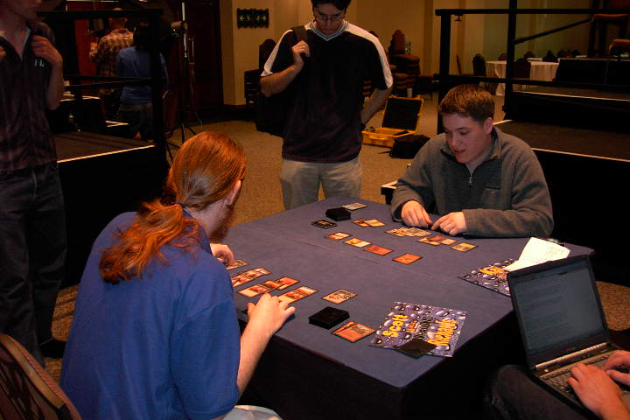
- Then, well, then there was Kai and I promise, he knows, I could have defeated him. I was just there, you know...
- No, I wouldn't mind at all if Kai creamed me. That's what playing is about... I do mind my mistake!
- Let me explain the game. Kai started with 10 life & 5 cards playing with Legends. The first match he got Tahngarth on the third turn. Nothing for me to do. I was 0-1.
- The second game, I just creamed him. I got Dwarves and then more Dwarves he couldn't do anything. We were 1-1.
- Then, I don't know. I got had the game in my hand and I just didn't pump the Dwarf to kill Tahngarth. Ask me why? I don't know. Just pressure?
- I believe that final games are what make great players shine. You are in front of them. You can win with the cards and then you'll be in the finals. You are going to beat them, but in a way it's like that's too much for you. Like the cards are there, but you are not ...
- Sorry man... this stuff sounds like Jim Carrey. Yak!
- I learned a lot playing with Kai. Afterwards, I played basketball with the other players and I enjoyed the game and the relaxation.
- By the way, Jon Finkel plays basketball really well and it's good to play with somebody that likes a sport as much as I do. The two Dutch guys were fun. I'm afraid it was their first basketball game. But they learned quick! Cornelissen is really fast at basketball you know, maybe he was just making up for his slow play all weekend. He's a cool guy though, just as shy as I am.
- What about another toast?
- For the Central American players:

SALUD!
- How do I feel? You mean about my result? Kind of happy. I told you. I got a third place for my people. A bronze medal in our Magic Olympics. Not that bad.
- But the real thing is what we can share now in Latin America. You learn, and you pass it on to your friends. I want one of them to be there next year. I feel that we need more international participation and a type of Magic Clinics in Latin America, like in tennis.
You need to play, but also you need to think a lot, and to be updated in what the top people is doing. And for that, the Invitational was great.
- That's the point, man. We are all players, and the game is competitive. But you grow only when you have a team, and when you share things. I mean. I learned a lot from playing with and talking to good players on the net. But not all the people in Latin America can do that because not all the people have the technology. Those with the technology must spread the wisdom. This is how it works in Montevideo and in many other places over there.
- Yeah, pretty different isn't it? I mean... you really need to like Magic a lot!
- Anyway, we'll make it. I hope that what I achieved in Cape Town will help people feel more confident when it comes to international events.
- For Latin America, the Invitational, and for all Magic players:

SALUD!!!

